OCList

# Overview

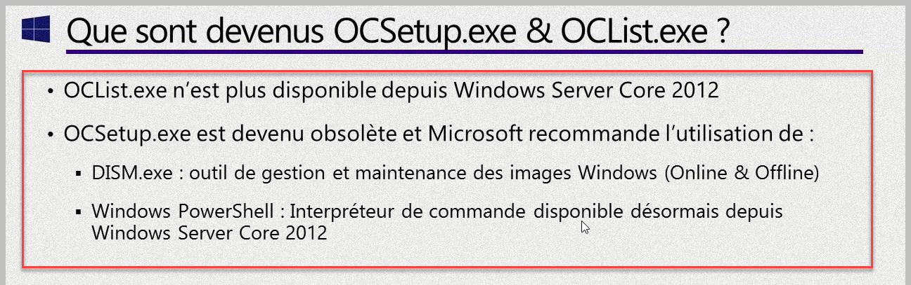

# DISM

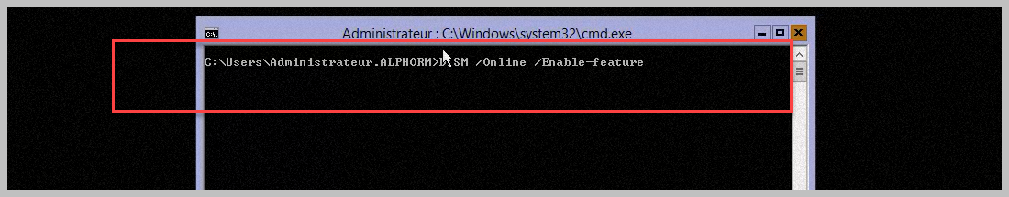

# DISM

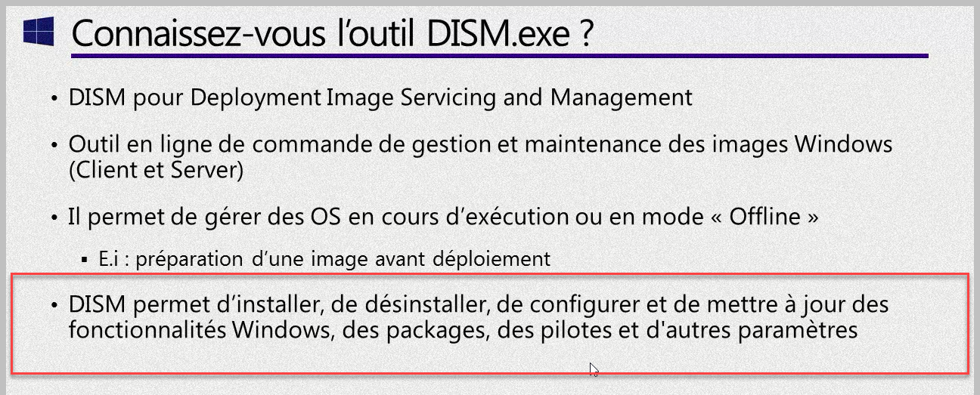

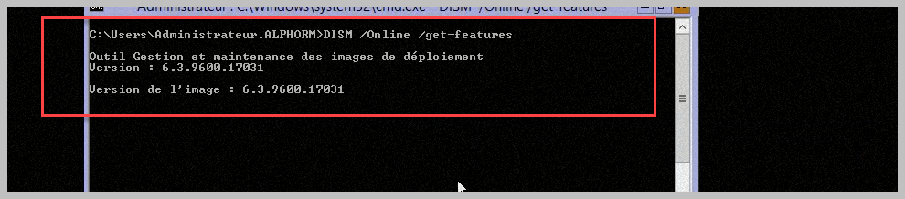

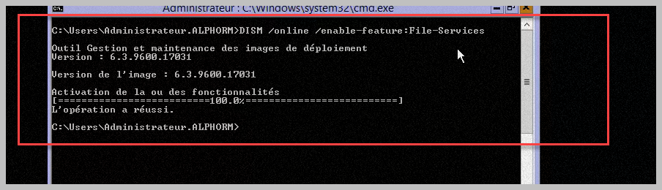

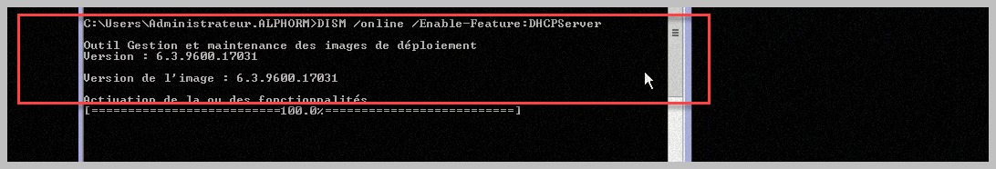

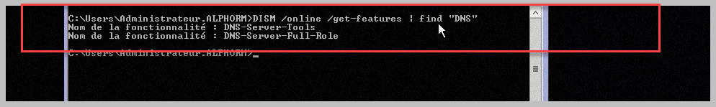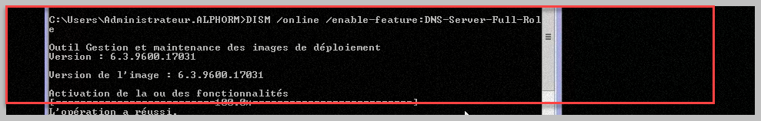

# Windows Powershell

